Vendor Application Form
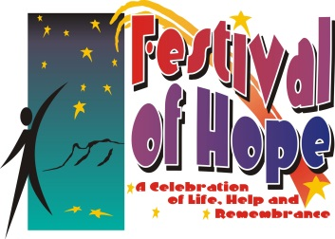
Festival of Hope Event
Saturday, June 15, 2024
7:30 a.m.-10:30 a.m.
Mitchell Event Center
Mitchell, Nebraska

Type of Booth
Health Information (no fee): ____
Retail Sales (choose one): $50.00 Fee_____ or 100 % of day’s proceeds _____

Vendor Information
Business Name: __________________________________________________
Contact Person: __________________________________________________
Address: ________________________________________________________
Email: __________________________________________________________
Website or Social Media: ___________________________________________
Phone/Cell Phone: ________________________________________________
Electrical outlet needed (limited space): Yes _____ No _____
Table/Chairs Needed (List number requested): Yes _____ No _____
Table # _____Chair # _____
Please list types of products, services and/or information that will be on display at your booth. Provide detailed description of your work and offerings. For example, how you make your product, what goes into the process, or why it is unique. Family Friendly content only please.
_______________________________________________________________________________________________________________________________________________________________________________________________________________________________________________________________________________________________________________________________________________
Send completed form to: Festival of Hope P.O. Box 377 Scottsbluff, NE 69363

Festival of Hope reserves the right to monitor and excuse content of sales and/or information from the Event at its discretion.

A Festival of Hope committee member will be in contact to confirm and with setup details.
Contact Amber at 308.765.2224 if no reply within 1-2 weeks of submitting form.

